
PROJECT REPORT
Personal To-Do App
React.js Course Project Documentation
Detail | Information
Name | Dinesh Shahi
Np code | Np071094
College | Techspire College
Subject | React.js
Instructor Name | Saman Thakuri
Build Tool | Vite
Project Type | Single-pack task management application
GitHub Repository | https://github.com/dineshshahif25-spec/To-do-list

Table of Contents
1. Introduction
2. Project Objectives
3. System Overview
4. Modules and Features
5. Technology Stack
6. Project Structure
7. User Interface and Screenshots
8. Installation and Setup
9. Functional Workflow
10. Known Limitations
11. Future Enhancement Areas
12. Conclusion
13. References

1. Introduction
TaskMaster is a single-page task management application developed using React.js. The application is designed to help users create, organize, update, complete, and remove daily tasks through a simple browser-based interface.
The project was developed as a practical React.js course project to apply fundamental concepts such as functional components, props, state management with hooks, event handling, controlled forms, conditional rendering, reusable components, and client-side persistence.

1.1 Project Scope
- Create tasks with a title, category, and optional due date.
- Edit existing tasks directly within the task list.
- Delete tasks when they are no longer required.
- Mark tasks as completed and display visual completion feedback.
- Filter tasks by All, Active, or Completed status.
- Organize tasks into Work, Personal, and Urgent categories.
- Persist tasks and theme preferences using browser localStorage.
- Support light and dark themes and responsive mobile layouts.

2. Project Objectives
The main objectives of the project are:
- Build a practical single-page application using React.js.
- Apply React functional components and hooks in a real-world use case.
- Practice controlled forms and event handling for user input.
- Implement state-driven task creation, editing, deletion, and completion.
- Use reusable components to keep the interface organized and maintainable.
- Implement client-side persistence with the localStorage API.
- Apply CSS variables, Flexbox, and media queries for theming and responsive design.
- Use Git and GitHub for version control and incremental project development.

3. System Overview
TaskMaster operates entirely on the client side. The React application manages the task data and user interface in the browser, while localStorage is used to retain tasks and theme preferences between page refreshes.
Area | Description
Application type | Single-page task management application
User interaction | Task entry, editing, deletion, completion, filtering, and theme switching
Task categories | Work, Personal, Urgent
Persistence | Browser localStorage
Responsive support | Desktop and mobile layouts
Backend | No backend service or database is used
Authentication | No user authentication is implemented

3.1 High-Level Application Flow
- The user enters task information through the task input form.
- React event handlers process the submitted information and update application state.
- The task list is rendered from the current state.
- Users can edit, delete, complete, or filter tasks.
- The application stores task and theme information in localStorage so it remains available after refresh.

4. Modules and Features

4.1 Core Task Management
Feature | Description
Add Tasks | Creates a task with title, category, and optional due date using a controlled form.
Edit Tasks | Allows the user to modify task title, category, and due date inline.
Delete Tasks | Removes a selected task from the list.
Mark as Complete | Toggles completion status using a custom checkbox with visual feedback.
Status Filtering | Displays All, Active, or Completed tasks.
Category Organization | Uses Work, Personal, and Urgent categories with distinct badges.
Live Task Counts | Displays remaining and completed task counts in real time.
localStorage Persistence | Keeps tasks and theme preferences after browser refreshes.

4.2 Additional / Stretch Features
- Due dates with overdue indicators: overdue tasks are highlighted with a red border and warning icon.
- Dark/light theme toggle with the selected preference persisted in localStorage.
- Responsive design using CSS media queries for smaller screens.

4.3 User Experience States
- Normal task-list state showing active and completed tasks.
- Filtered views for All, Active, and Completed tasks.
- Empty state when no tasks are available.
- Light and dark visual themes.
- Mobile-responsive task entry and task-list layout.

5. Technology Stack
Technology / Tool | Purpose
React 18 | Builds the user interface using functional components and hooks.
Vite | Provides development tooling, a fast development server, and optimized builds.
CSS3 | Provides styling, CSS variables for themes, Flexbox layout, and responsive media queries.
localStorage API | Stores tasks and theme preferences in the browser.
Git & GitHub | Tracks project changes and development progress through version control.

5.1 React Concepts Applied
- Functional components for reusable interface sections.
- Props for passing data and behavior between components.
- useState for managing application state.
- useEffect for handling persistent state synchronization.
- Event handling for form submission, editing, deletion, completion, and theme changes.
- Conditional rendering for task states, filters, overdue indicators, and empty-state messaging.

6. Project Structure
The project follows a component-based structure:
react-todo-app/
├── src/
│ ├── components/
│ │ ├── TaskInput
│ │ ├── TaskList
│ │ ├── TaskItem
│ │ ├── FilterBar
│ │ └── ThemeToggle
│ ├── hooks/
│ │ └── useLocalStorage
│ ├── App.jsx
│ ├── App.css
│ └── index.css
└── package.json
File / Folder | Responsibility
src/components/ | Contains reusable interface components.
TaskInput | Handles task input and submission.
TaskList | Displays the collection of tasks.
TaskItem | Represents an individual task and its actions.
FilterBar | Provides task filtering controls.
ThemeToggle | Controls light/dark theme switching.
src/hooks/ | Contains reusable custom React hooks.
useLocalStorage | Supports persistent client-side state.
App.jsx | Main application component and data flow.
App.css | Application/component styling and theme-related styles.
index.css | Global styles and theme variable definitions.

7. User Interface and Screenshots
The supplied project includes screenshots demonstrating the main interface, theme switching, responsive mobile behavior, and the empty-task state.
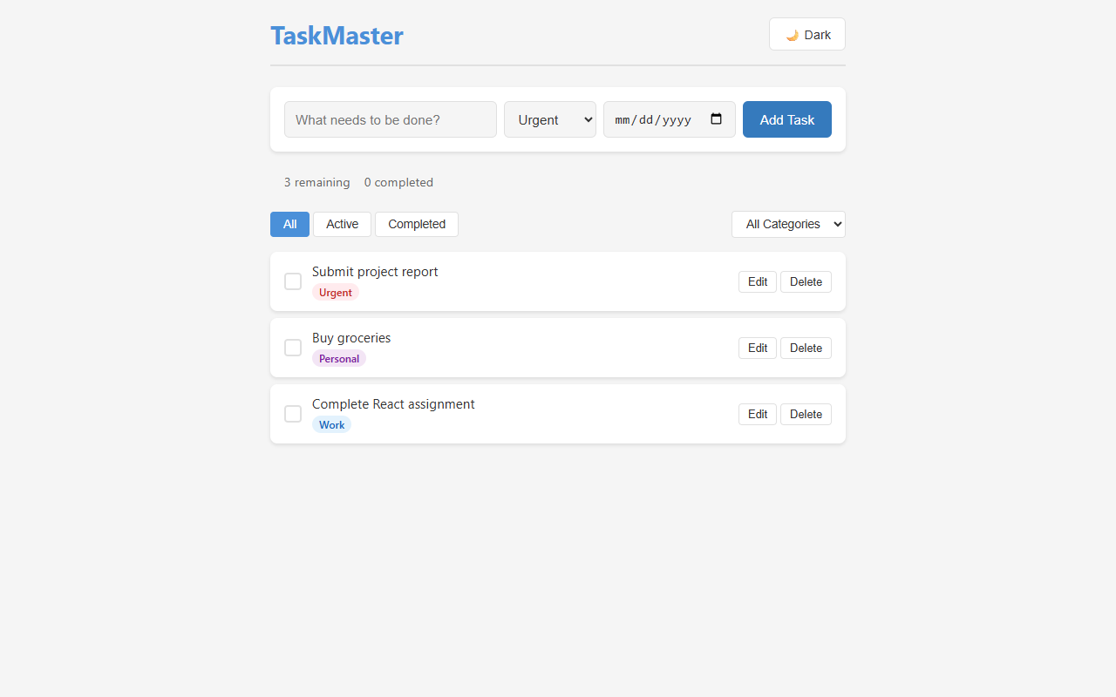
Figure 1. Main TaskMaster view with tasks, categories, filters, and task actions.
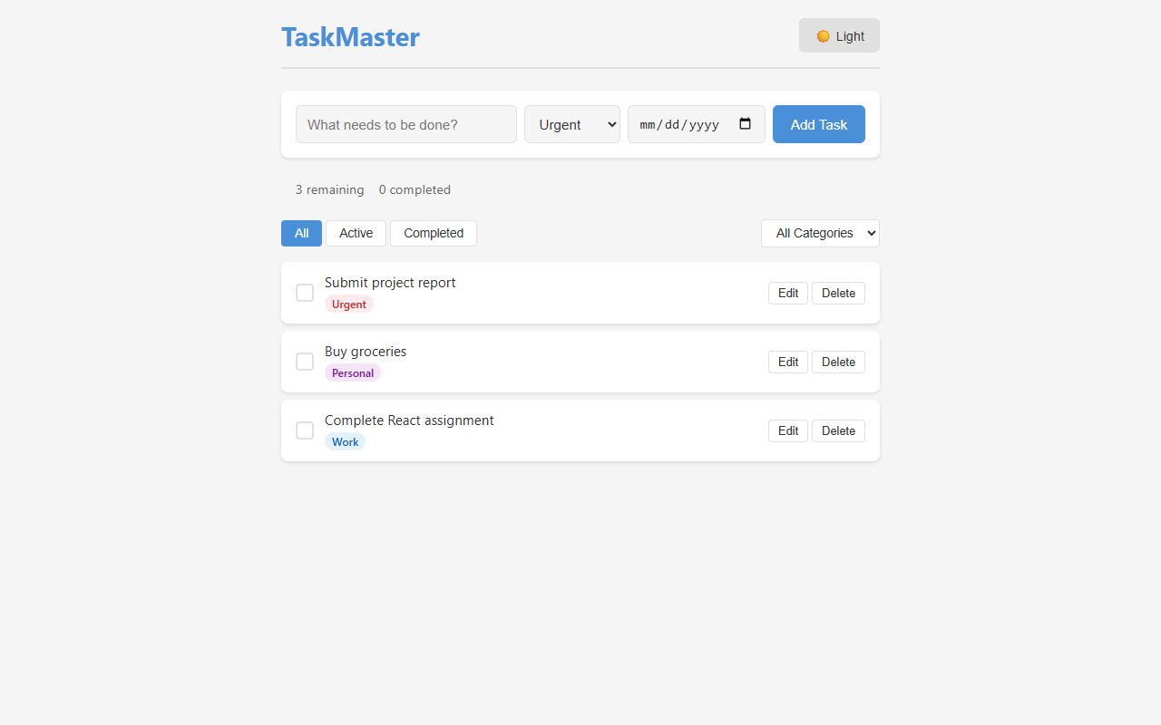
Figure 2. Theme toggle demonstrated in the alternate light/dark interface state.
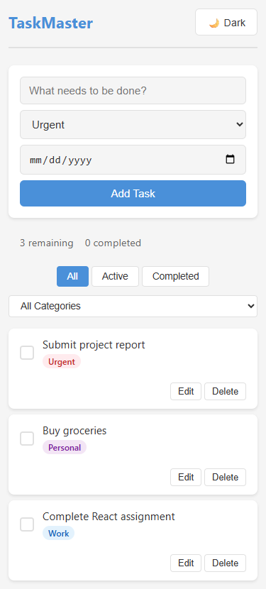
Figure 3. Responsive mobile layout.
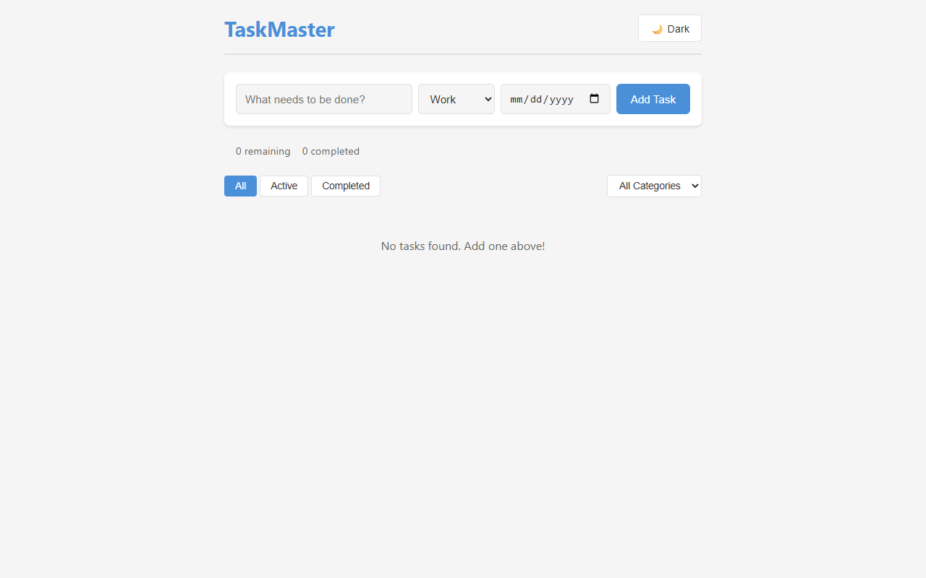
Figure 4. Empty state displayed when there are no tasks.

8. Installation and Setup

8.1 Prerequisites
- Node.js version 16 or higher.
- npm installed and available in the terminal.
- A modern web browser.

8.2 Setup Procedure
- Clone the project repository to the local machine.
- Open a terminal and navigate to the project directory.
- Install project dependencies using npm.
- Start the Vite development server.
- Open the local development address shown by Vite in a web browser.
Commands:
cd react-todo-app
npm install
npm run dev
The supplied documentation specifies the development address as http://localhost:5173 after starting the development server.

9. Functional Workflow

9.1 Creating a Task
- Enter a task title in the task input field.
- Select a category: Work, Personal, or Urgent.
- Optionally select a due date.
- Submit the form using Add Task.
- The new task appears in the task list and the live counts update.

9.2 Managing an Existing Task
- Use the checkbox to mark the task as completed or active.
- Use Edit to modify the task information inline.
- Use Delete to remove the task.
- Use the status filters to display All, Active, or Completed tasks.
- Use the category control to organize or view tasks by category.

9.3 Persistence
Task data and theme preferences are stored using the browser's localStorage API. This allows the information to survive a page refresh without requiring a server-side database.

10. Known Limitations
Limitation | Impact
No drag-and-drop reordering | Tasks remain in the order in which they were added.
No backend database | Data is stored only in browser localStorage and is not synchronized across devices.
No user authentication | The application does not provide separate user accounts.
Inline edit mode | Editing replaces the task card content instead of opening a modal dialog.

11. Future Enhancement Areas
The following are natural extension areas based on the limitations documented for the current version:
- Add drag-and-drop task reordering.
- Introduce a backend database for centralized and cross-device persistence.
- Add user authentication and account-based task management.
- Provide a dedicated modal dialog for task editing.

12. Conclusion
TaskMaster demonstrates the practical use of React.js for building an interactive single-page application. The project combines reusable components, hooks, event handling, controlled forms, conditional rendering, responsive CSS, theme management, and browser-based persistence in one application.
The resulting application provides the core functionality expected from a personal to-do system while also demonstrating additional features such as due dates, overdue indicators, theme switching, live task counts, and responsive design.

13. References
- React Documentation: https://react.dev
- Vite Documentation: https://vitejs.dev
- MDN Web Docs — localStorage: https://developer.mozilla.org/en-US/docs/Web/API/Window/localStorage
- MDN Web Docs — CSS Custom Properties: https://developer.mozilla.org/en-US/docs/Web/CSS/Using_CSS_custom_properties
Project note: The supplied source documentation states that the project was developed as part of a React.js course curriculum and that the code was written for learning purposes.

